[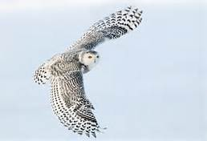](http://www.bing.com/images/search?q=snowy+owls&qs=n&form=QBIR&pq=snowy+owls&sc=0-0&sp=-1&sk=#view=detail&id=A631560849B82C982A0ED8AEDD7FB12A4C9B4321&selectedIndex=2)[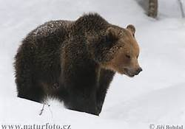](http://www.bing.com/images/search?q=brown+bear&qs=n&form=QBIR&pq=brown+bear&sc=0-1&sp=-1&sk=#view=detail&id=D0F8E5668F1DDBC81F19D13C91FB6AC75446E5A8&selectedIndex=20)[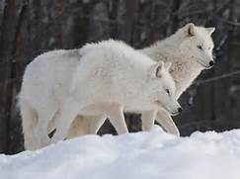](http://www.bing.com/images/search?q=arctic+wolves&FORM=AWIR#view=detail&id=416642C3D457B866A6745F91B1FEFE2FF4EA3DFC&selectedIndex=0)[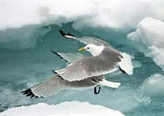](http://www.bing.com/images/search?q=kittiwakes&FORM=AWIR#view=detail&id=1115EF1E46EE01E03BBB215964922148F46344B4&selectedIndex=13)[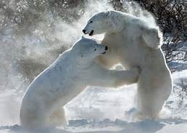](http://www.bing.com/images/search?q=polar+bears&qs=n&form=QBIR&pq=polar+bears&sc=0-3&sp=-1&sk=#view=detail&id=2833F2B46C83A7DDB68BA2B21E65CBF63764886C&selectedIndex=104)

Brown Bear

Artic Woflf

Polar Bear

[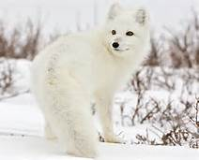](http://www.bing.com/images/search?q=arctic+fox&qpvt=arctic+fox&FORM=IGRE#view=detail&id=C5E303321F54AD996F5AC27C9F11D3C81C27184E&selectedIndex=2)

Kittiwake

Snowy owl

**[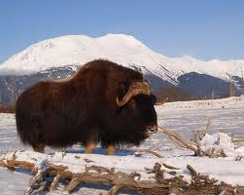](http://www.google.com/imgres?q=musk+ox&safe=active&biw=1600&bih=792&tbm=isch&tbnid=wcSA7SiLtnXe1M:&imgrefurl=http://scienceblogs.com/laelaps/2010/03/10/of-all-the-mass-extinctions/&docid=U1na5MFDbd4kIM&imgurl=http://scienceblogs.com/laelaps/wp-content/blogs.dir/435/files/2012/04/i-d69c2447f37fecdd96f57ea831f5fbd7-musk-ox-photo-thumb-500x399-42395.jpg&w=500&h=399&ei=YUZxUoiyIqTdsAT1wYCACg&zoom=1&ved=1t:3588,r:4,s:0,i:91&iact=rc&page=1&tbnh=170&tbnw=208&start=0&ndsp=25&tx=81&ty=96)**

Artic Fox

**[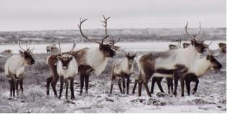](http://www.google.com/imgres?q=caribou&safe=active&biw=1600&bih=792&tbm=isch&tbnid=NTmQYR4-1FduMM:&imgrefurl=http://www.enr.gov.nt.ca/_live/pages/wpPages/caribou_information.aspx&docid=6fTW2hA36tfEzM&imgurl=http://www.enr.gov.nt.ca/_live/images/rad/caribou_herd.jpg&w=1704&h=861&ei=XkdxUov-NfPgsAS25oHQAg&zoom=1&ved=1t:3588,r:0,s:0,i:79&iact=rc&page=1&tbnh=159&tbnw=316&start=0&ndsp=24&tx=118&ty=79)[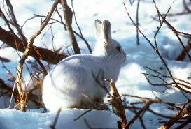](http://www.google.com/imgres?q=arctic+hare&safe=active&sa=X&hl=en&biw=1600&bih=792&tbm=isch&tbnid=b4nC6elrFGRRbM:&imgrefurl=http://commons.wikimedia.org/wiki/File:Arctic_Hare.jpg&docid=m3ZTI76FowPU0M&imgurl=http://upload.wikimedia.org/wikipedia/commons/d/d5/Arctic_Hare.jpg&w=3193&h=2162&ei=hUhxUtatIbKjsQSM2IDoAg&zoom=1&ved=1t:3588,r:12,s:0,i:117&iact=rc&page=1&tbnh=181&tbnw=255&start=0&ndsp=26&tx=115&ty=73)**

**[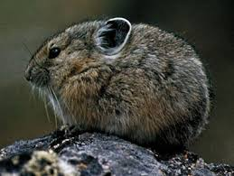](http://www.google.com/imgres?q=pika&safe=active&biw=1600&bih=792&tbm=isch&tbnid=iU0UYVwcniVeFM:&imgrefurl=http://www.britannica.com/blogs/2011/10/pintsized-pika-challenged-climate-change/&docid=BPuRg8qSIqZ8TM&imgurl=http://media-3.web.britannica.com/eb-media/16/3516-004-67E3395A.jpg&w=399&h=300&ei=jUZxUsTnO8_LsQT_wICgBg&zoom=1&ved=1t:3588,r:4,s:0,i:91&iact=rc&page=1&tbnh=177&tbnw=249&start=0&ndsp=24&tx=93&ty=81)**

Artic Hare

Musk Ox

**[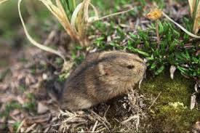](http://www.google.com/imgres?q=lemmings&safe=active&bih=792&biw=1600&tbm=isch&tbnid=WKHpgJYGkne0UM:&imgrefurl=http://www.biology-blog.com/blogs/permalinks/4-2007/will-lemmings-fall-off.html&docid=00W3C3EPHyQLZM&imgurl=http://www.biology-blog.com/images/blogs/4-2007/lemmings-2801.jpg&w=400&h=267&ei=HkhxUuGdFLHLsQTRsIGoBg&zoom=1&ved=1t:3588,r:8,s:0,i:103&iact=rc&page=1&tbnh=179&tbnw=275&start=0&ndsp=24&tx=220&ty=38)**

Caribou

[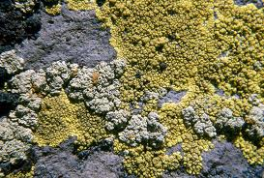](http://www.google.com/imgres?q=crustose+lichen&safe=active&biw=1600&bih=792&tbm=isch&tbnid=aPUeDe-Xq1wzMM:&imgrefurl=http://www.nps.gov/features/yell/slidefile/plants/lichen/Page.htm&docid=nkw_ldg3uFDAvM&imgurl=http://www.nps.gov/features/yell/slidefile/plants/lichen/Images/08225.jpg&w=1999&h=1350&ei=DkVxUpqBBs7JsQSEqIDYAQ&zoom=1&ved=1t:3588,r:5,s:0,i:94&iact=rc&page=1&tbnh=173&tbnw=248&start=0&ndsp=25&tx=101&ty=58)[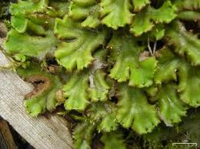](http://www.google.com/imgres?q=liverworts&safe=active&sa=X&biw=1600&bih=792&tbm=isch&tbnid=go4CEEQ2iIlNIM:&imgrefurl=http://www.waysofenlichenment.net/wells/mosses&docid=k9BvtqUEGfVBlM&imgurl=http://www.waysofenlichenment.net/images/wells/random_liverwort.jpg&w=330&h=247&ei=dkRxUqeXIvavsQT39IDICg&zoom=1&ved=1t:3588,r:10,s:0,i:111&iact=rc&page=1&tbnh=184&tbnw=239&start=0&ndsp=28&tx=99&ty=129)[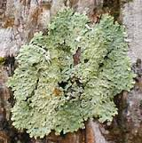](http://www.google.com/imgres?q=foliose+lichen&safe=active&biw=1600&bih=792&tbm=isch&tbnid=Xmvut8QvjHD5gM:&imgrefurl=http://www.backyardnature.net/lichen-2.htm&docid=BmsmCjUnodK1lM&imgurl=http://www.backyardnature.net/pix/lichen_f.jpg&w=200&h=202&ei=SkVxUvHxHqTMsQS1-YCoAg&zoom=1&ved=1t:3588,r:3,s:0,i:88&iact=rc&page=1&tbnh=161&tbnw=156&start=0&ndsp=27&tx=104&ty=95)[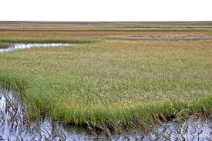](http://www.google.com/imgres?q=tundra+grass&safe=active&bih=792&biw=1600&tbm=isch&tbnid=lilpWdxjRtNkwM:&imgrefurl=http://simplebooklet.com/publish.php?wpKey=LNXMaG0EgDJpAwlRq4v510&docid=tVWkFC1B9qnLqM&imgurl=http://simplebooklet.com/userFiles/a/7/5/4/3/4/LNXMaG0EgDJpAwlRq4v510/SCieiHFv.jpg&w=800&h=534&ei=2kVxUsuaLdLLsQS45YDgBg&zoom=1&ved=1t:3588,r:7,s:0,i:100&iact=rc&page=1&tbnh=172&tbnw=258&start=0&ndsp=26&tx=235&ty=144)[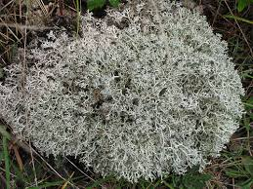](http://www.google.com/imgres?q=caribou+moss&safe=active&biw=1600&bih=792&tbm=isch&tbnid=z_8It3TltzMFnM:&imgrefurl=http://lucasgarcia1.edublogs.org/&docid=kRpx-4-_N1NZDM&imgurl=http://lucasgarcia1.edublogs.org/files/2011/03/caribou-moss-2f8c894.jpg&w=500&h=375&ei=vERxUobuI6vJsQS6ioGIAQ&zoom=1&ved=1t:3588,r:2,s:0,i:85&iact=rc&page=1&tbnh=187&tbnw=232&start=0&ndsp=25&tx=149&ty=116)

Lemming

Pika

Artic grass

Crustose lichen

Foliose lichen

Caribou Moss

Liverwort